Daniela CSS DINNER

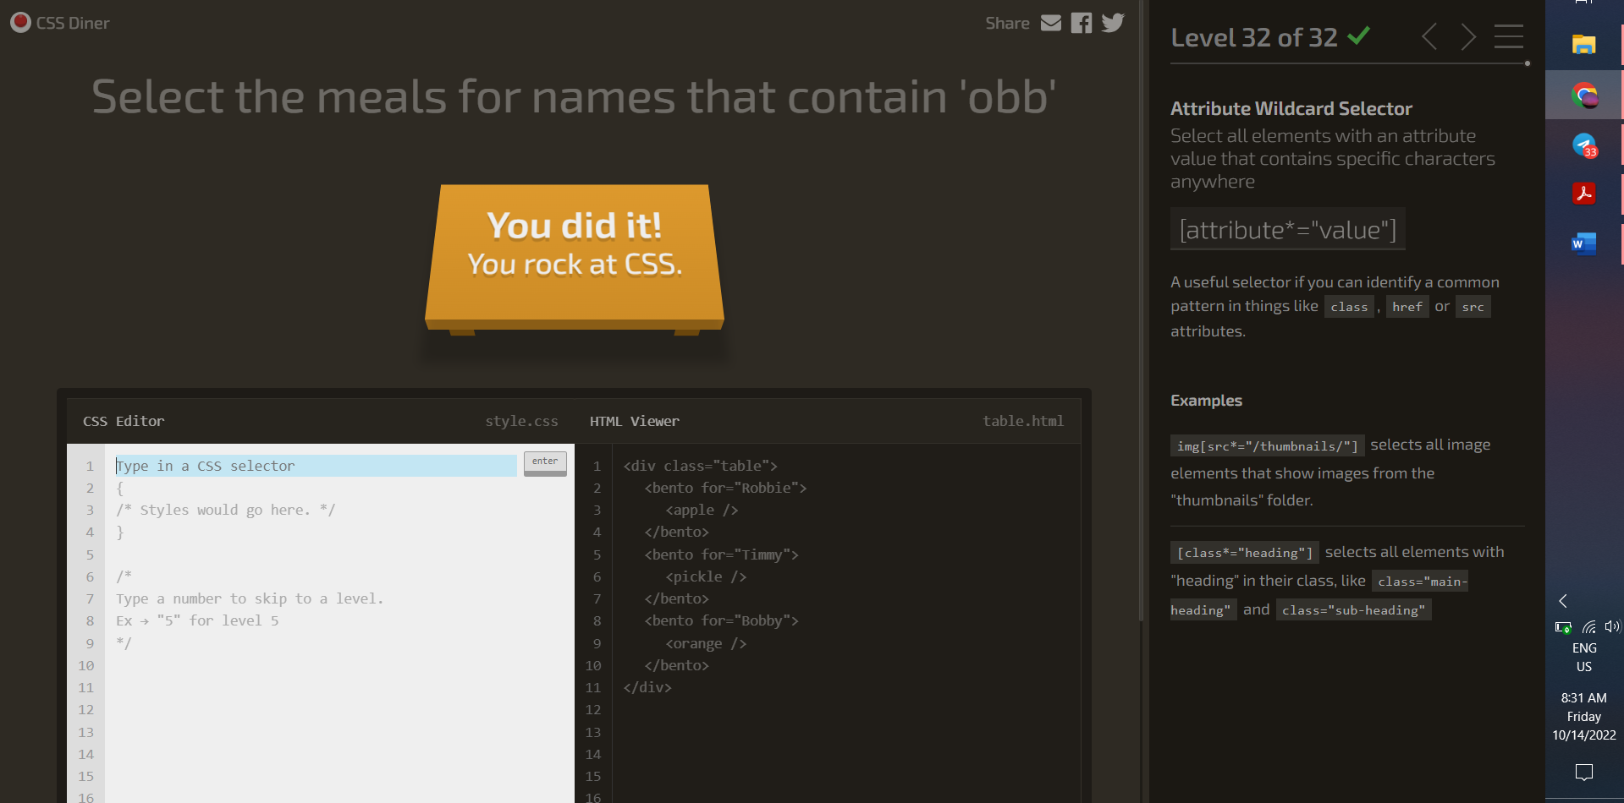



|  |  |  |
| --- | --- | --- |
|  |  |  |
|  |  |  |
|  |  |  |
|  |  |  |
|  |  |  |
|  |  |  |
|  |  |  |
|  |  |  |

<div></div>

<style>

*{

background:#5d3a3a;

margin:0;

}

div {

width: 200px;

height: 200px;

background: #b5e0ba;

}

</style>

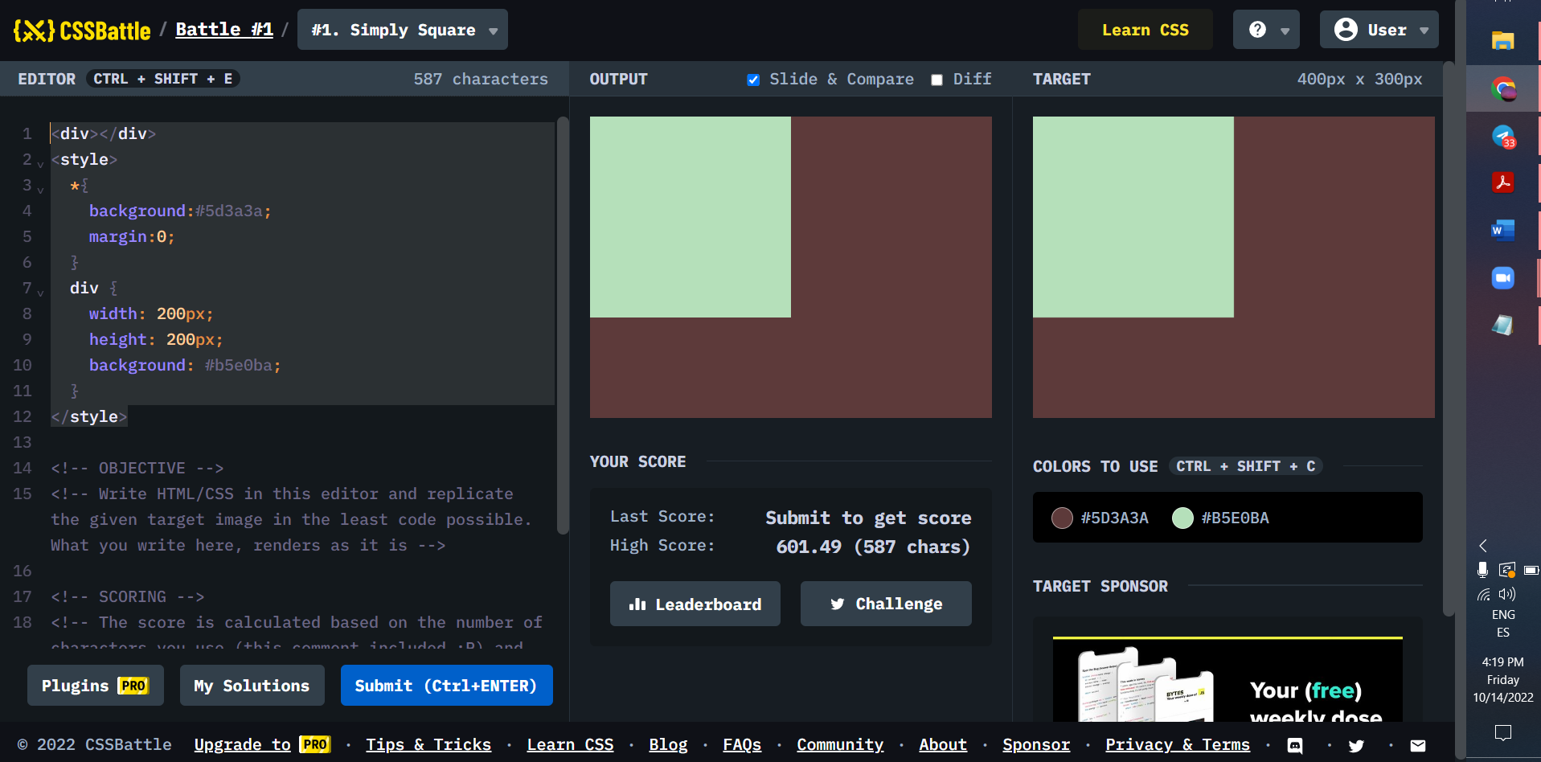

<div id="contenedor1">

<div class="A"></div>

<div class="A"></div>

</div>

<div id="contenedor2">

<div class="A"></div>

<div class="A"></div>

</div>

<style>

*{

margin:0;

padding:0;

background:#62374e;

}

#contenedor1 {

width:300;

height:50;

margin:50;

display:flex;

justify-content:space-between;

}

#contenedor2 {

width:300;

height:50;

margin-top:100;

margin-left:50;

display:flex;

justify-content:space-between;

}

.A{

width:50;

height:50;

background: #fdc57b;

}

<div class="cuadrado"></div>

<div class="circulo"></div>

<div class="circulo2"></div>

<div class="circulo3"></div>

<style>

*{

background:#6592CF;

margin:0;

}

#contenedor{

}

.cuadrado {

width: 300px;

height: 150px;

background:#243D83 ;

margin-top:75;

margin-left:50;

}

.circulo {

margin-top:-200;

margin-left:75;

width: 250px;

height: 250px;

-moz-border-radius: 50%;

-webkit-border-radius: 50%;

border-radius: 50%;

background: #6592CF;

}

.circulo2 {

margin-top:-200;

margin-left:125;

width: 150px;

height: 150px;

-moz-border-radius: 50%;

-webkit-border-radius: 50%;

border-radius: 50%;

background: #243D83;

}

.circulo3 {

margin-top:-100;

margin-left:175;

width: 50px;

height: 50px;

-moz-border-radius: 50%;

-webkit-border-radius: 50%;

border-radius: 50%;

background: #EEB850;

}

</style>

<div id="container1">

<div class="semi-circulo"></div>

<div class="rectangulo"></div>

</div>

<div id="container2">

<div class="rectangulo"></div>

<div class="semi-circulo2"></div>

<div class="rectangulo2"></div>

<div class="semi-circulo22"></div>

</div>

<style>

*{

background:#62306D;

margin:0;

}

#container1 {

width: 100px;

height: 100px;

margin-top:50;

margin-left:150;

}

#container2 {

width: 300px;

height: 100px;

margin-top:;

margin-left:50;

}

.semi-circulo{

background:#F7EC7D;

width: 100px;

height: 50px;

border: 0;

-moz-border-radius: 100px 100px 0 0;

-webkit-border-radius: 100px 100px 0 0;

border-radius: 100px 100px 0 0;

}

.semi-circulo2{

background:#F7EC7D;

width: 100px;

height: 50px;

border: 0;

border-radius: 0 0px 100px 100px;

}

.rectangulo{

width:100px;

height:50px;

background:#F7EC7D;

}

.semi-circulo22{

background:#F7EC7D;

width: 100px;

height: 50px;

border: 0;

border-radius: 0 0px 100px 100px;

margin-left:200;

}

.rectangulo2{

margin-top:-100;

margin-left:200;

width:100px;

height:50px;

background:#F7EC7D;

}

</style>

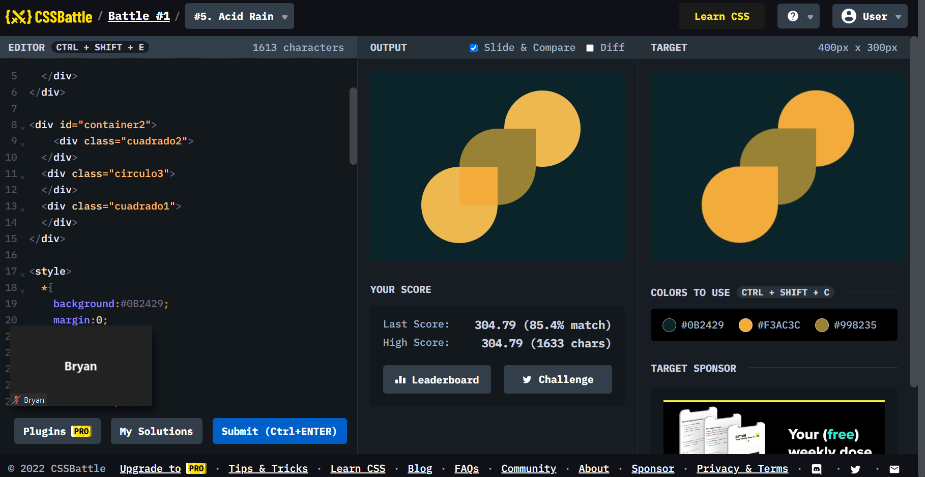

<div id="contenedor">

<div class="uno">

</div>

<div class="dos">

</div>

<div class="tres">

</div>

</div>

<style>

*{

background:#E3516E;

margin:0;

}

#contenedor{

margin-top:50px;

margin-left:100px;

width: 200px;

height: 200px;

background: #E3516E;

display:flex;

flex-wrap:wrap;

}

.uno {

width: 100px;

height: 100px;

background: #51B5A9;

border-radius: 100% 0 0 0;

}

.dos {

width: 100px;

height: 100px;

background: #FADE8B;

border-radius: 0 100% 0 0;

}

.tres {

width: 100px;

height: 100px;

background: #F7F3D7;

border-radius: 0 0 0 100%;

}

</style>

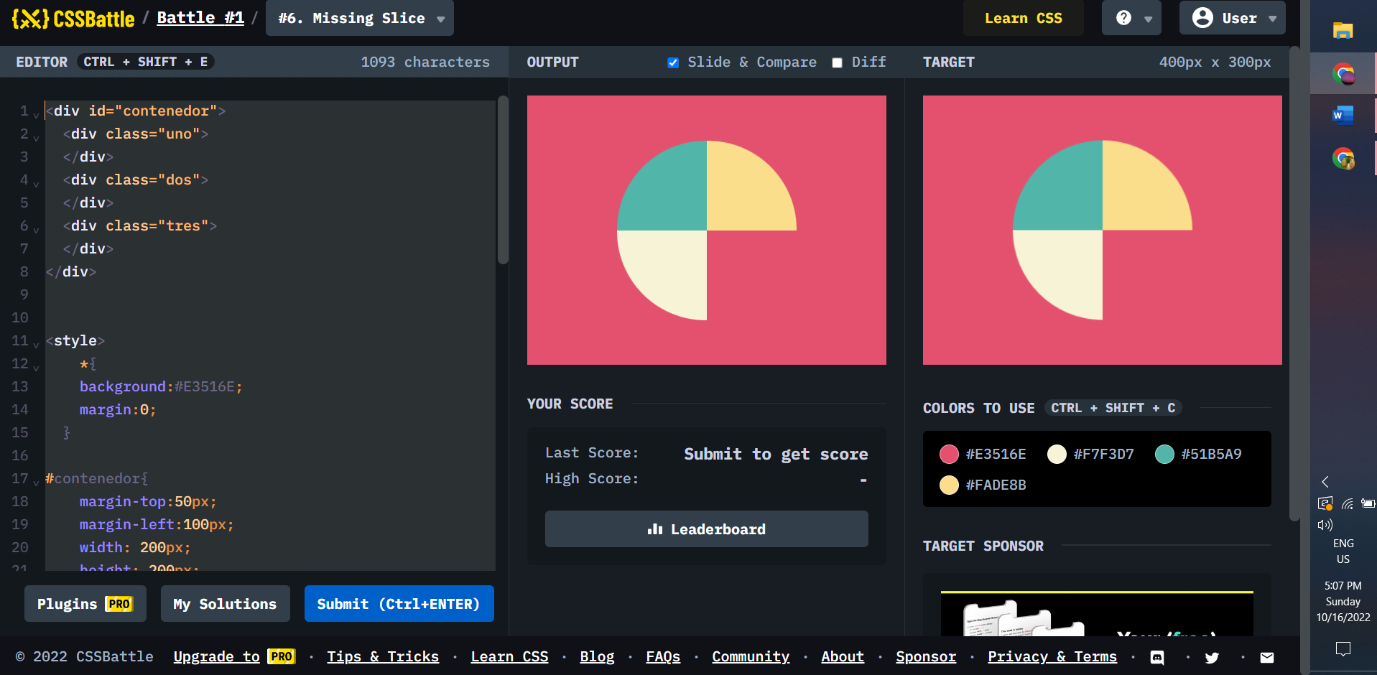

<div id="contenedor" >

<div id="contenedor1">

<div class="uno">

</div>

<div class="dos">

</div>

<div class="tres">

</div>

</div>

<div id="contenedor2">

<div class="uno1">

</div>

<div class="dos2">

</div>

<div class="tres3">

</div>

</div>

<div id="contenedor3">

<div class="uno11">

</div>

<div class="dos22">

</div>

<div class="tres33">

</div>

<div class="cuatro">

</div>

</div>

</div>

<style>

*{

margin:0;

style:"position: relative";

}

#contenedor{

width: 400px;

height: 300px;

background:#0B2429;

display:flex;

flex-wrap:wrap;

position: relative;

}

#contenedor1{

position: absolute;

z-index:1;

margin-top:75px;

margin-left:75px;

width: 250px;

height: 150px;

display:flex;

flex-wrap:wrap;

}

.uno {

width: 100px;

height: 100px;

background: #1A4341;

border-radius: 100% 0 0 0;

}

.dos {

width: 150px;

height: 20px;

background: #1A4341;

}

.tres {

width: 100px;

height: 50px;

background: #1A4341;

}

#contenedor2{

position: absolute;

z-index:2;

margin-top:75px;

margin-left:125px;

width: 200px;

height: 150px;

display:flex;

flex-wrap:wrap;

}

.uno1 {

width: 100px;

height: 100px;

background: #998235;

border-radius: 100% 0 0 0;

}

.dos2 {

width: 50px;

height: 100px;

background: #998235;

}

.tres3 {

width: 100px;

height: 50px;

background: #998235;}

#contenedor3{

position: absolute;

z-index:3;

margin-top:75px;

margin-left:175px;

width: 150px;

height: 150px;

display:flex;

flex-wrap:wrap;

}

.uno11 {

width: 100px;

height: 100px;

background: #F3AC3C;

border-radius: 100% 0 0 0;

}

.dos22 {

width: 50px;

height: 50px;

background: #F3AC3C;

}

.tres33 {

width: 50px;

height: 50px;

background: #F3AC3C;}

.cuatro {

margin-top:-50px;

width: 100px;

height: 100px;

background: #F3AC3C;

border-radius: 0 0 100% 0;

</style>

</style>

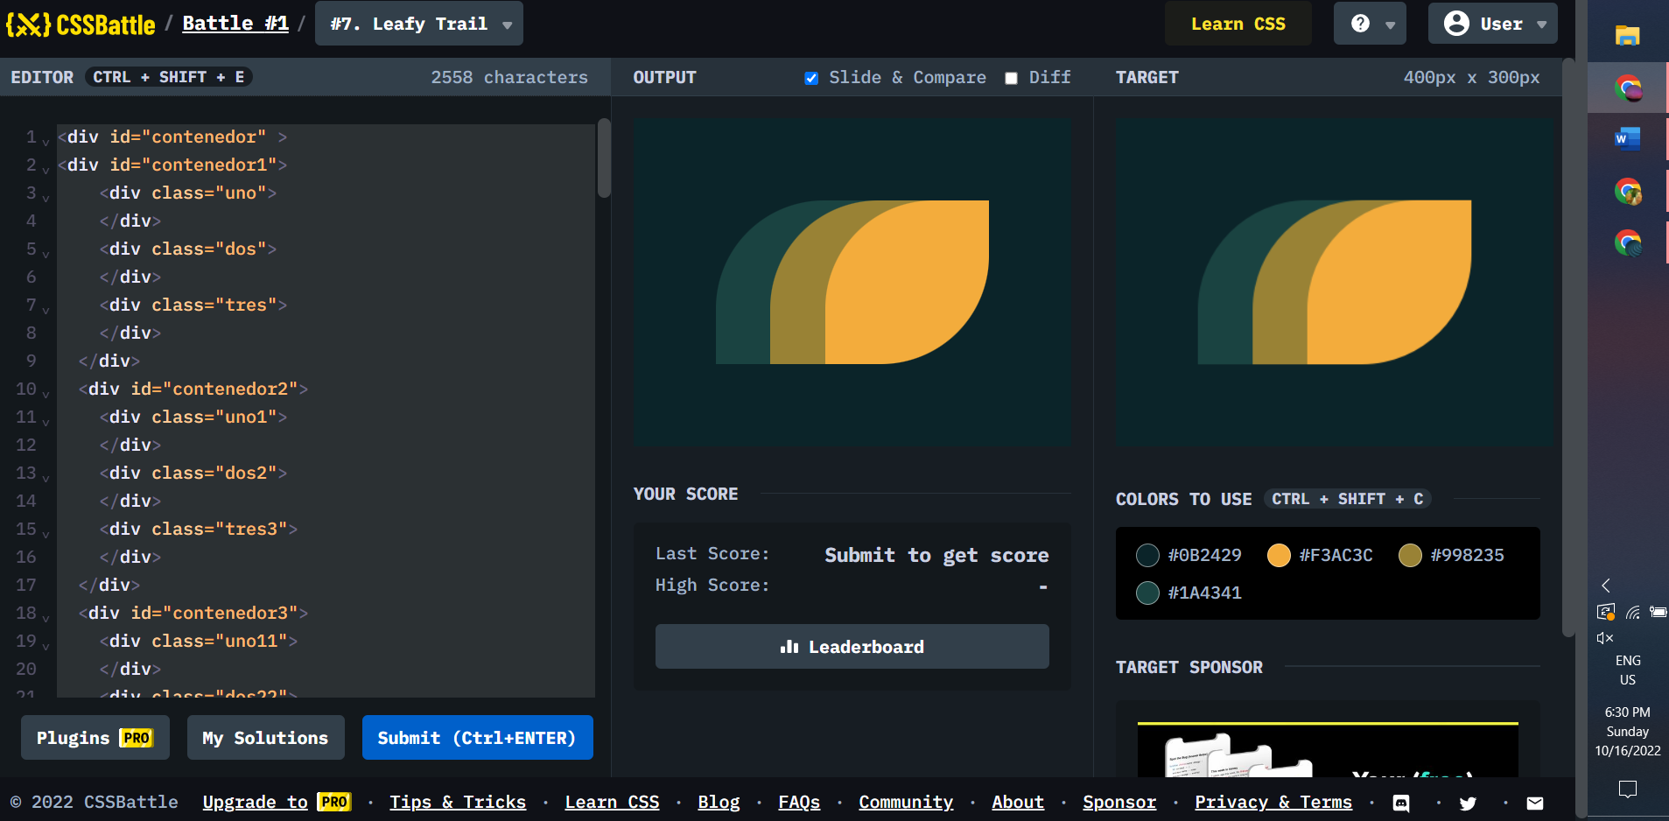

<div id="contenedor">

<div id="contenedor1">

<div id="t1">

<div class="c">

</div>

<div class="r">

</div>

</div>

<div id="s1">

<div class="r1">

</div>

<div class="c1">

</div>

</div>

<div id="t1">

<div class="c">

</div>

<div class="r">

</div>

</div>

<div id="s1">

<div class="r1">

</div>

<div class="c1">

</div>

</div>

<div id="t1">

<div class="c">

</div>

<div class="r">

</div>

</div>

<div id="s1">

<div class="r1">

</div>

<div class="c1">

</div>

</div>

<div id="t1">

<div class="c">

</div>

<div class="r">

</div>

</div>

</div>

<div class="circulo">

</div>

<div id="contenedor3">

</div>

</div>

<style>

*{

margin:0;

background: #6592CF;

}

#contenedor{

margin-top:50;

margin-left:130;

width: 140px;

height: 250px;

background:#6592CF;

display:flex;

flex-wrap:wrap;

}

#contenedor1{

width: 140px;

height: 110px;

background:#0605;

display:flex;

flex-wrap:wrap;

}

.circulo{

width: 140px;

height:90px;

background: #060F55;

border-radius: 0 0 100px 100px;

}

#contenedor3{

margin-left:60;

width: 20px;

height: 60;

background: #060F55;

}

#t1{

width: 20px;

height: 110px;

}

#s1{

background: #060F55;

}

.c{

width: 20px;

height: 20px;

border-radius: 100px 100px 0 0 ;

background: #060F55;

}

.r{

width: 20px;

height: 100px;

background: #060F55;

}

.r1{

width: 20px;

height: 100px;

background: #6592CF;

}

.c1{

width: 20px;

height: 10px;

border-radius: 0 0 100px 100px ;

background:#6592CF ;

}

</style>

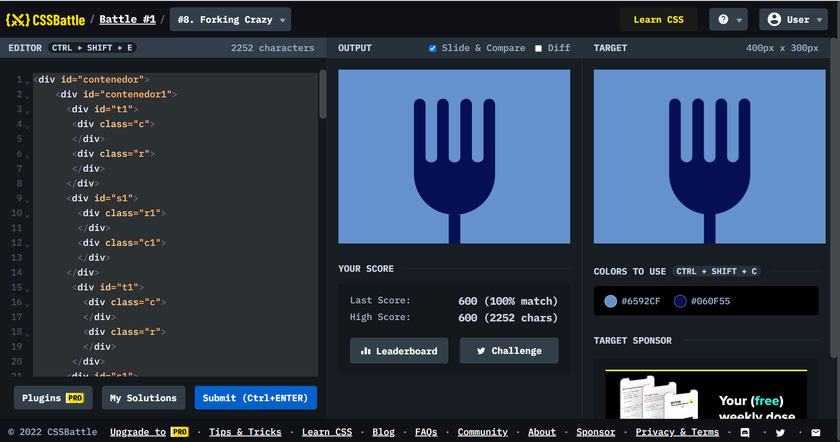

<div id="rect">

<div class="fondo">

</div>

</div>

<div id="rombo1">

</div>

<div id="rombo">

</div>

<div id="rombo2">

</div>

<div id="circulo">

</div>

<style>

*{

background:#222730;

margin:0;

}

#rect {

position: absolute;

z-index:1;

margin-top:75px;

width: 400px;

height: 150px;

display:flex;

flex-wrap:wrap;

background:#4CAAB3;

}

#rombo1 {

position: absolute;

z-index:2;

margin-left:55;

margin-top:75;

width: 150px;

height: 150px;

background: #222730;

-webkit-transform: rotate(45deg);

-moz-transform: rotate(45deg);

-ms-transform: rotate(45deg);

-o-transform: rotate(45deg);

transform: rotate(45deg);

}

#rombo {

position: absolute;

z-index:3;

margin-left:125;

margin-top:75;

width: 150px;

height: 150px;

background: #4CAAB3;

-webkit-transform: rotate(45deg);

-moz-transform: rotate(45deg);

-ms-transform: rotate(45deg);

-o-transform: rotate(45deg);

transform: rotate(45deg);

}

#rombo2 {

position: absolute;

z-index:2;

margin-left:195;

margin-top:75;

width: 150px;

height: 150px;

background: #222730;

-webkit-transform: rotate(45deg);

-moz-transform: rotate(45deg);

-ms-transform: rotate(45deg);

-o-transform: rotate(45deg);

transform: rotate(45deg);

}

#circulo{

position: absolute;

margin-left:175;

margin-top:125;

z-index:4;

background:#393E46;

width: 50px;

height: 50px;

border-radius: 100px 100px 100px 100px ;

}

.fondo{

background:#222730;

width: 200px;

margin-left:100;

}

</style>

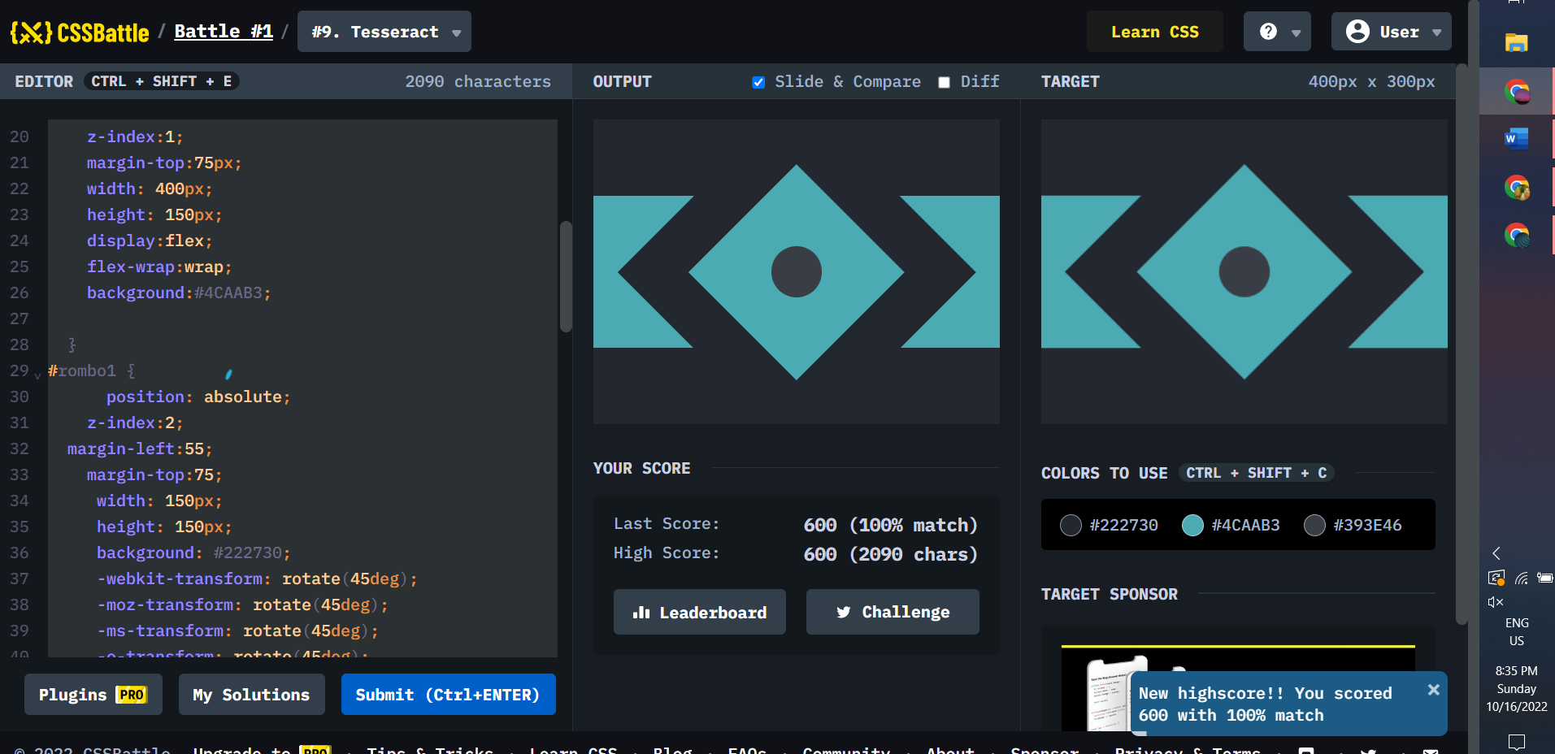

<div id="fondo">

<div id="externo">

<div class="v">

</div>

<div class="h">

</div>

</div>

<div id="externo2">

<div id="arriba">

<div class="cm">

<div class="cr">

</div>

</div>

</div>

<div id="abajo">

<div class="ce">

<div class="cn">

</div>

</div>

<div class="ce">

<div class="cn">

</div>

</div>

</div>

</div>

</div>

<style>

*{

margin:0;

}

#fondo{

width: 400px;

height: 300px;

position: relative;

background:#62306D;

}

#externo {

position: absolute;

z-index:1;

margin-top:50;

margin-left:50;

width: 300px;

height: 250px;

display:flex;

flex-direction:column;

align-items:center;

}

#externo2 {

position: absolute;

z-index:2;

margin-top:50;

margin-left:50;

width: 300px;

height: 200px;

display:flex;

flex-direction:column;

align-items:center;

}

.v{

width:100;

height:150;

background: #F7EC7D;

border-radius: 100px 100px 0 0;

}

.h{

width:300;

height:100;

background: #F7EC7D;

}

#arriba{

width:300;

height:100;

display:flex;

justify-content:center;

}

#abajo{

width:300;

height:100;

display:flex;

justify-content:space-between;

}

.ce{

width:100;

height:100;

background: #AA445F;

border-radius: 50%;

display:flex;

align-items:center;

justify-content:center;

}

.cn{

width:60;

height:60;

background: #E38F66;

border-radius: 50%;

align-self:center;

}

.cm{

width:100;

height:100;

background: #E38F66;

border-radius: 50%;

display:flex;

align-items:center;

justify-content:center;

}

.cr{

width:60;

height:60;

background: #AA445F;

border-radius: 50%;

align-self:center;

}

</style>

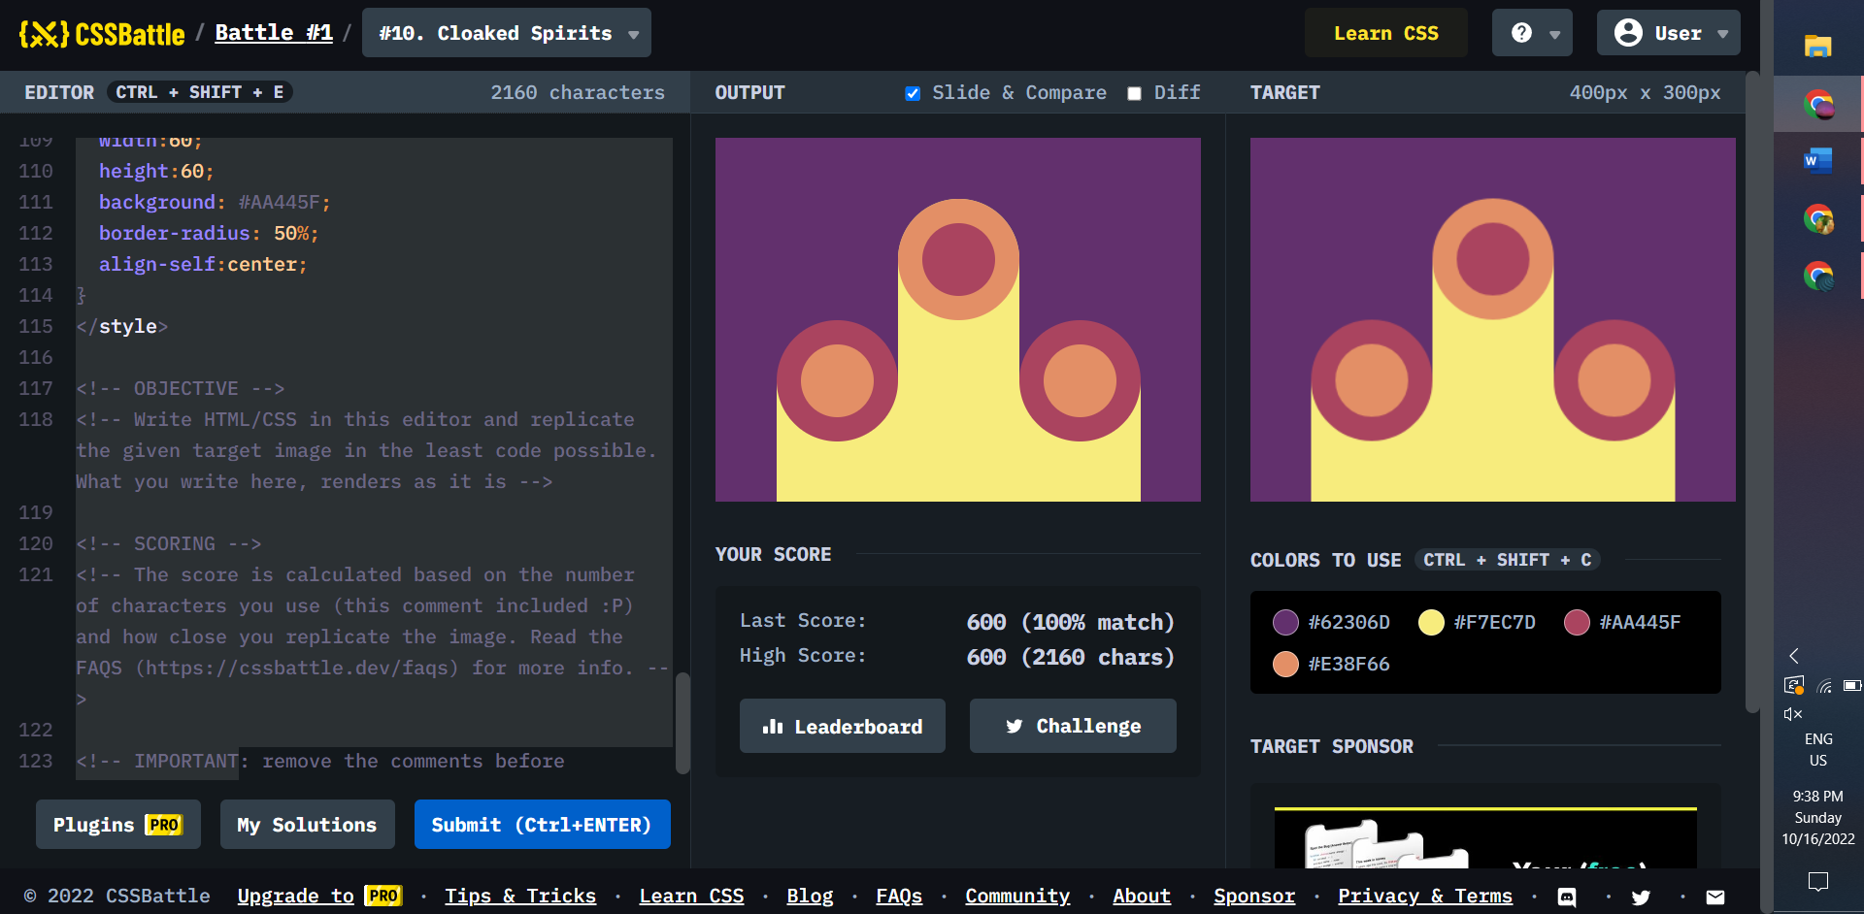

height: 140px;

z-index: 2;

margin-top:80;

margin-left:130;

}

.uno{

display:flex;

flex-direction:column;

justify-content:flex-end;

}

.cr{

width:50;

height:50;

background: #84271C;

border-radius: 50%;

display:flex;

align-items:center;

justify-content:center;

border-radius: 50%;

}

.cn{

width:100;

height:100;

background: #191210;

border-radius: 50%;

display:flex;

align-items:center;

justify-content:center;

border-radius: 50%;

}

.circulo{

width:140;

height:140;

background: #ECA03D;

border-radius: 50%;

display:flex;

align-items:center;

justify-content:center;

}

.ct{

width:100;

height:50;

background: #ECA03D;

border-radius: 50%;

display:flex;

margin-top:20;

justify-content:center;

border-radius: 100px 100px 0 0 ;

}

.cb{

margin-bottom:20;

width:100;

height:50;

background: #ECA03D;

border-radius: 50%;

display:flex;

justify-content:center;

border-radius: 0 0 100px 100px;

}

.cib{

margin-bottom:50;

width:60;

height:60;

background: #191210;

border-radius: 50%;

align-self:center;

}

.cit{

margin-top:50;

width:60;

height:60;

background: #191210;

border-radius: 50%;

align-self:center;

}

</style>

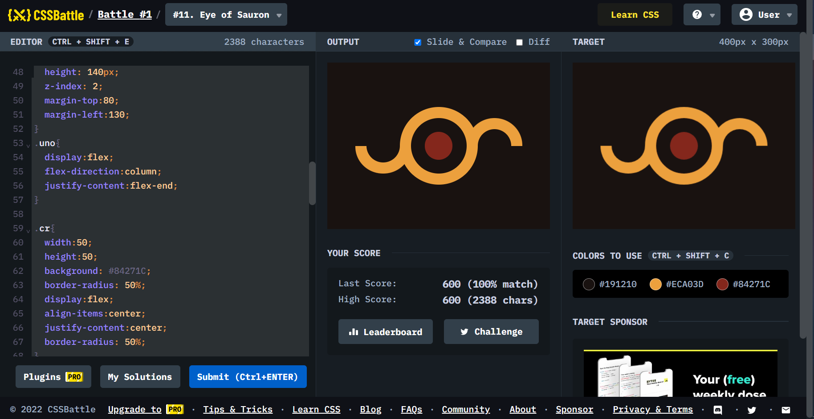

<div id="externo">

<div id="internoa">

<div class="tapita">

</div>

<div class="circulo2">

<div class="circuloInternoEx">

</div>

</div>

<div class="tapita">

</div>

</div>

<div id="internob">

<div class="circulo">

<div class="circuloInternoIn">

</div>

</div>

<div class="circulo">

<div class="circuloInternoIn">

</div>

</div>

</div>

</div>

<style>

*{

background:#F5D6B4;

margin:0;

}

#externo {

margin-top:100;

margin-left:70;

position:relative;

display:flex;

flex-direction:column;

width: 260px;

height: 100px;

justify-content:space-between;

}

#internoa{

width:260;

height:50;

display:flex;

justify-content:space-between;

align-items:flex-end;

}

#internob{

width:260;

height:50;

display:flex;

justify-content:space-between;

}

#uno{

z-index:1;

position:absolute;

width:100;

height:100;

display:flex;

flex-direction:column;

justify-content:flex-end;

}

#dos{

margin-left:75;

position:absolute;

z-index:1;

width:100;

height:100;

}

#tres{

position:absolute;

z-index:2;

margin-left:160;

width:100;

height:100;

display:flex;

flex-direction:column;

align-items:flex-end;

justify-content:flex-end;.

}

.tapita{

width:20;

height:10;

background:#D86F45;

border-radius: 100px 100px 0 0;

}

.circulo{

width:100;

height:50;

background:#D86F45;

border-radius:0 0 100px 100px ;

display:flex;

justify-content:center;

align-items:flex-start;

}

.circuloInternoIn{

width:60;

height:30;

background:#F5D6B4;

border-radius:0 0 100px 100px ;

}

.circuloInternoEx{

width:60;

height:30;

background:#F5D6B4;

border-radius:100px 100px 0 0 ;

}

.circulo2{

width:100;

height:50;

background:#D86F45;

border-radius:100px 100px 0 0 ;

display:flex;

justify-content:center;

align-items:flex-end;

}

}

